BEHAVIORAL ASSIGNMENTS
WAPP CONVO IN CASE U MISSED IT.

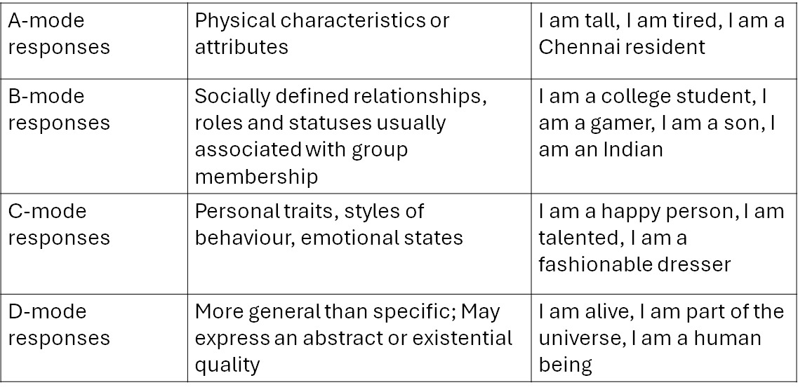
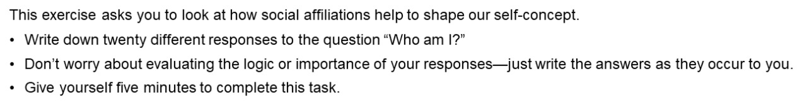
Now it’s time to score your responses according to the following four categories:
USE YOUR BEST JUDGEMENT
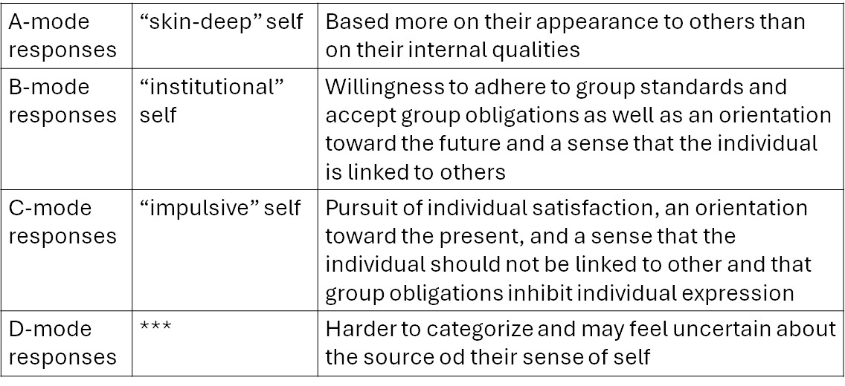
Submit your assignment
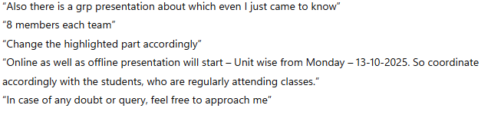
to-nidhip1@srmist.edu.in

